**MateBook X Pro Windows Update Guide**

Follow the below steps to update BIOS on your MateBook X Pro:

1. Before updating the BIOS, ensure that the following conditions are met:
2. The battery level is greater than 30%.
3. Your MateBook X Pro is connected to a charger.
4. The BIOS version of the current system is earlier than that of the installation package.

Note: To check the BIOS version : Press Win+R to open **Run**, input “msinfo32”,then check the BIOS Version.

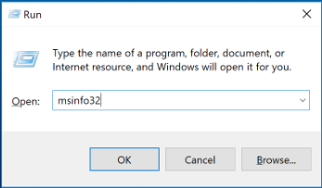

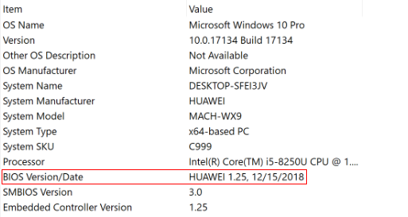

1. After preceding conditions are met, right-click the Mach file in the Windows update package you have downloaded and select **Install**.

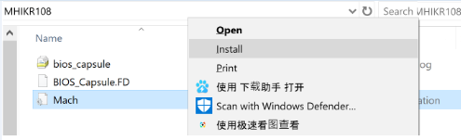

1. The following dialog box will then display automatically. You can select either **Restart Now** or **Restart Later**. The system will automatically install the BIOS upon next restart.

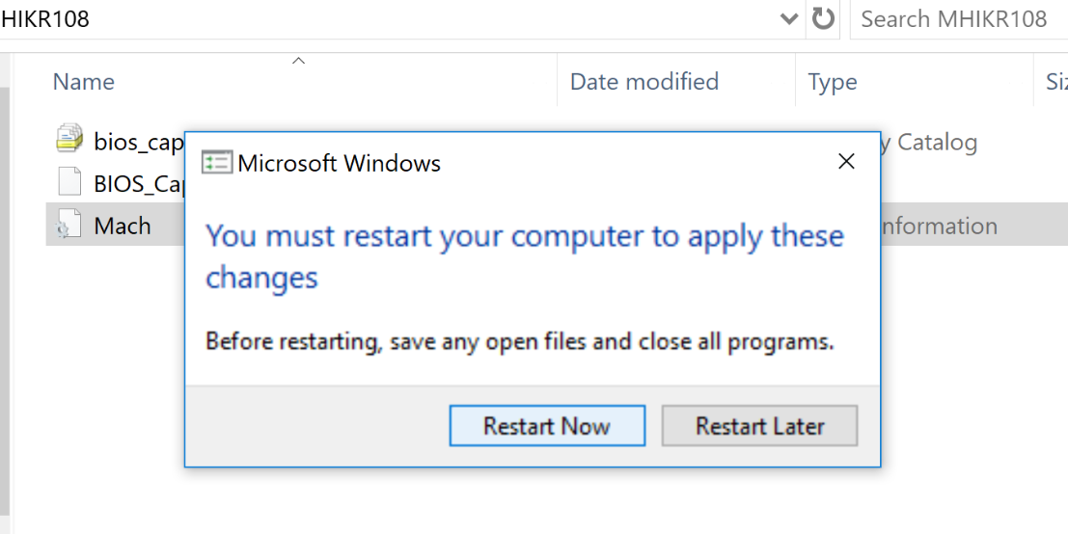

1. During the restart, the following BIOS update message is displayed.
2. Normal BIOS update



1. If your MateBook X Pro is not connected to a charger or its battery level is lower than 30%, the following message will be displayed. The update will be automatically performed when the aforementioned conditions are met.

